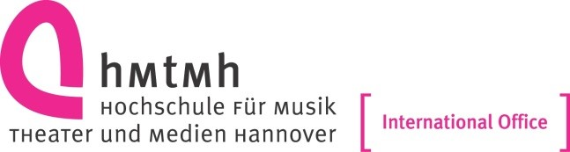

ERASMUS - Study
academic year 2024/25

Letter of confirmation for student stay abroad (SMS)

DEPARTURE

It is hereby certified that

Mr./Ms. _________________________________________________________

home university: University of Music, Drama and Media Hannover________
(D HANNOVE04)

was enrolled as an ERASMUS student at our institution

from ___________________________________________ (day, month, year)

to ___________________________________________ (day, month, year)

To be completed by the host institution:

___________________________________________ Name of host institution

_______________________________________ ID code of the host institution

_________________________________________________Name of signatory

________________________________________________________ Function

____________________________________________________________ Date

______________________________________________ Stamp and Signature

Please note that this certification should be filled at the end of the students
stay abroad!

International Office I Nathalie Lex
Loebensteinstr. 2
30175 Hannover
Tel.: +49 (0)511 3100-7369
internationaloffice@hmtm-hannover.de

